**ITPO DOMESTIC FAIRS PORTAL USER MANUAL**

**The URL of ITPO’s Domestic Fairs Portal is** [**https://domesticbooking.indiatradefair.com**](https://domesticbooking.indiatradefair.com/)

**STEPS REQUIRED FOR REGISTERING FOR A FAIR:**

1. **Sign-Up / User Registration**
2. **Login**
3. **Company Registration**
4. **Fair Registration**
5. **Verifying on Dashboard**

**1). Sign-Up / User Registration.**

➢If you have already signed up you can proceed to Step 2 (Login): -

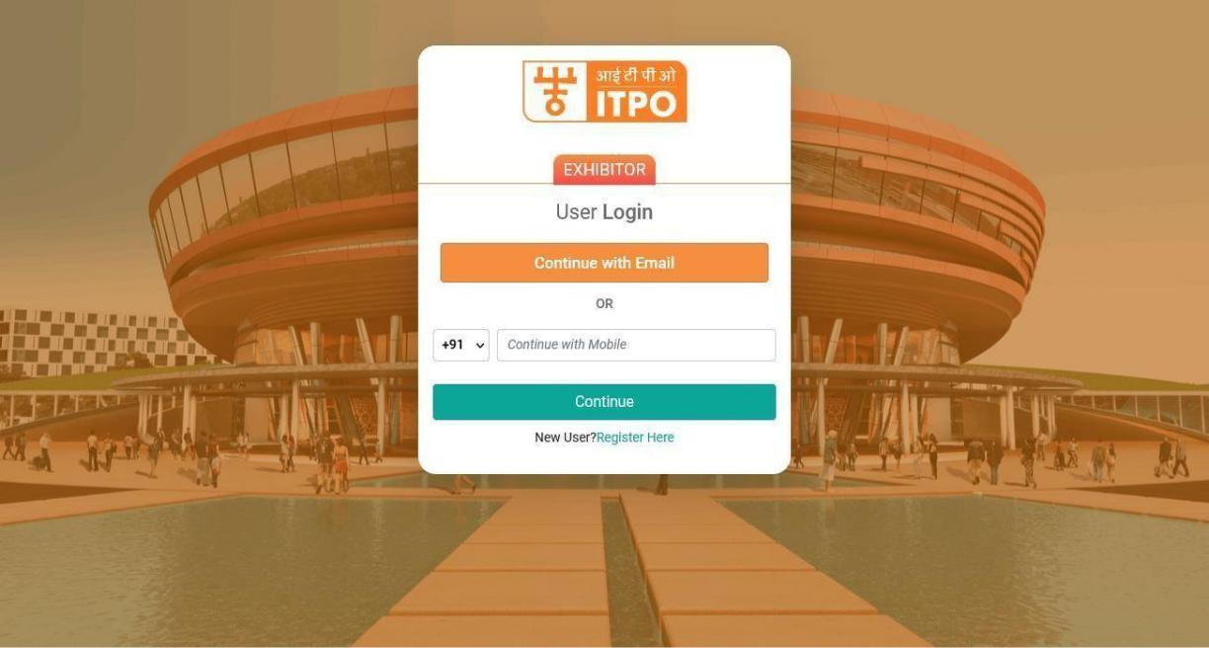

**Else, Click on Register Here Button :**

* Fill up the user registration form as given below : -

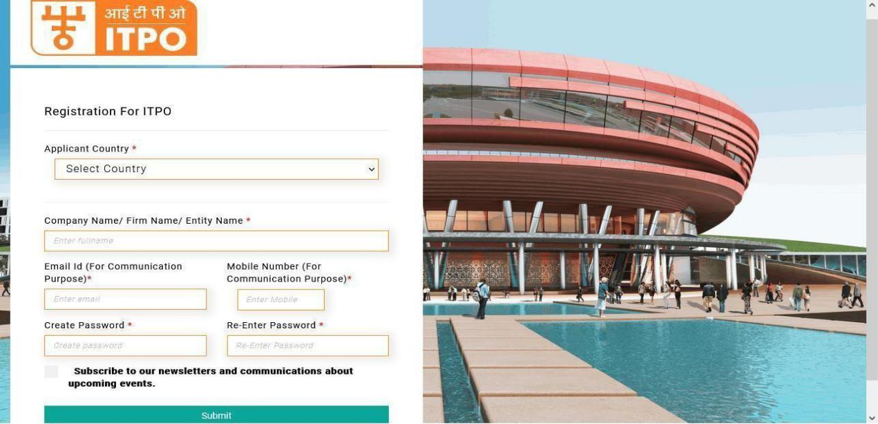

* Please note that numbers and special characters are not allowed in the Company Name/ Firm Name/ Entity Name field.
* Fill up this form and click on Submit.
* On the next screen, you will be asked to Verify OTP.
* Upon Successful registration you will receive confirmation via SMS and Email.

1. **Login (After Successful OTP verification).**
   * Continue to login using the email and password used in Step 1.

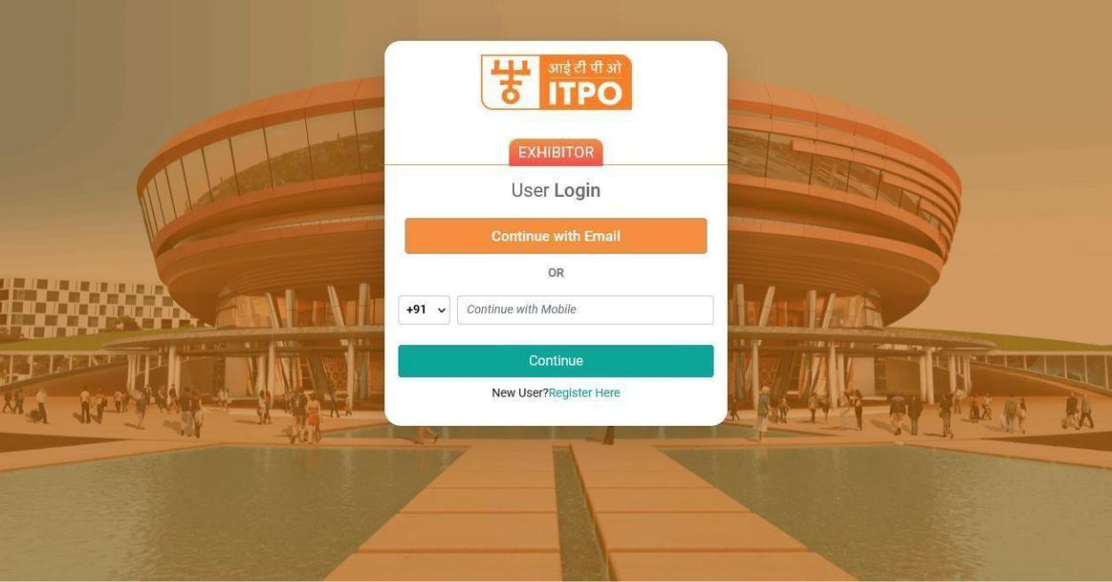

* After logging in the Company registration form opens.

1. **Company Registration.**
   * The users who have not yet registered their company/firm will see the company registration form on the landing page after login : -
   * You will require following documents handy while registering your company :
     + PAN (Mandatory) will be the unique identification for a company. Only one company can be registered using a PAN.
     + GSTIN (If Applicable)

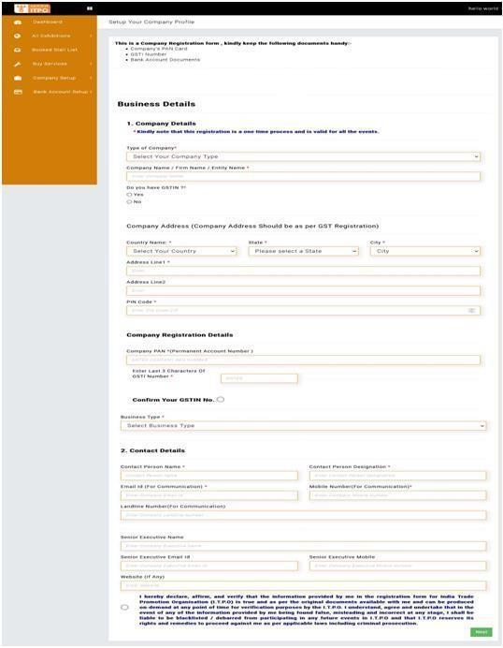

* After filling up the form, check and agree to the declaration and click on **Next**.
* Upon successful submission of the form, you will see a successful company registration page along with an SMS and Email confirmation on your registered mobile number and email id.

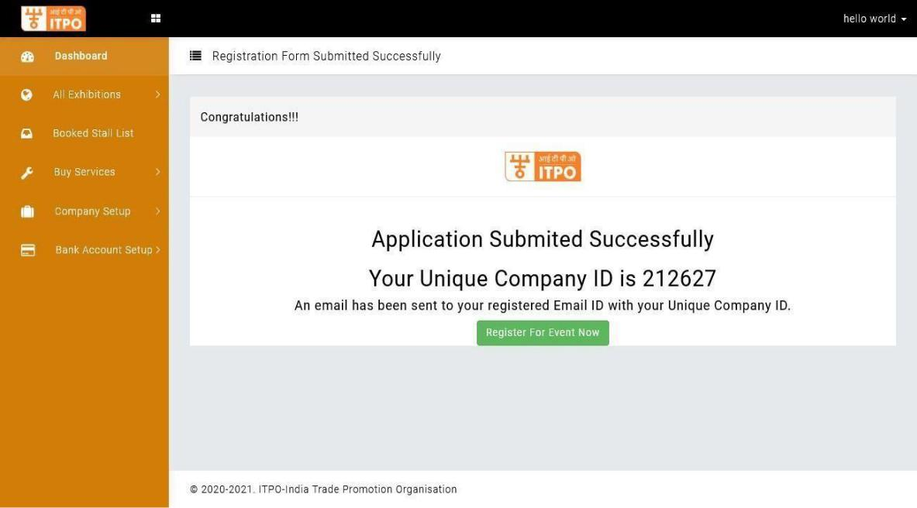

* On this page you can proceed straight to register for an upcoming events by clicking on Register for the Event Now button.

1. **Fair Registration**
   * Go to All Exhibitions -> Upcoming Exhibitions
   * You will see a list of Upcoming Exhibitions.

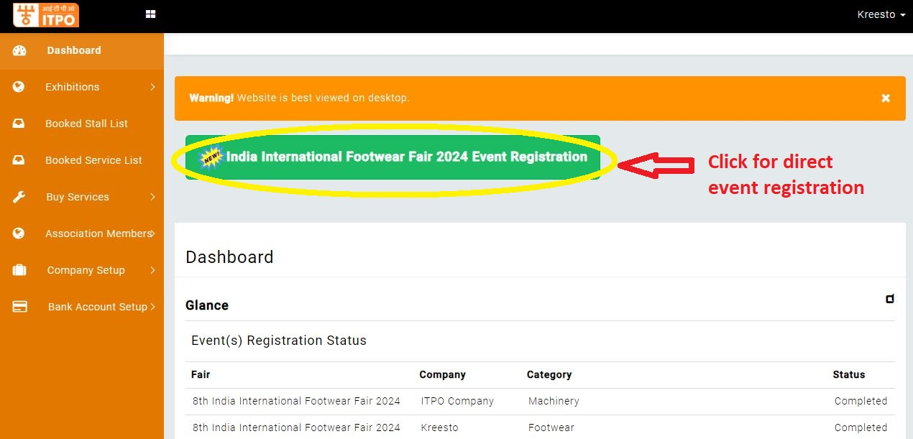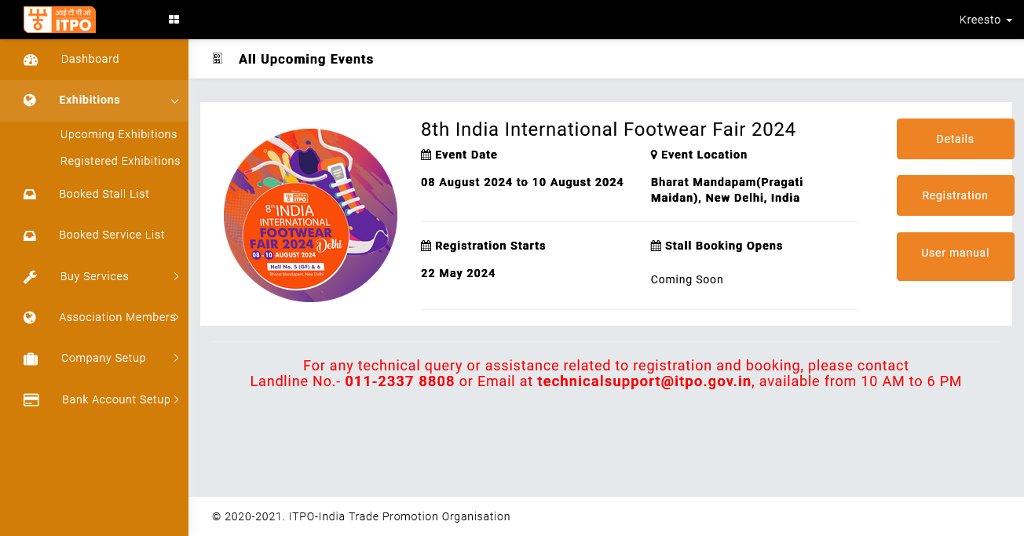

* Click on Register Button to register for the Fair.
* A Registration form will appear as:
* You will be asked to select your company for which the participation is intended.

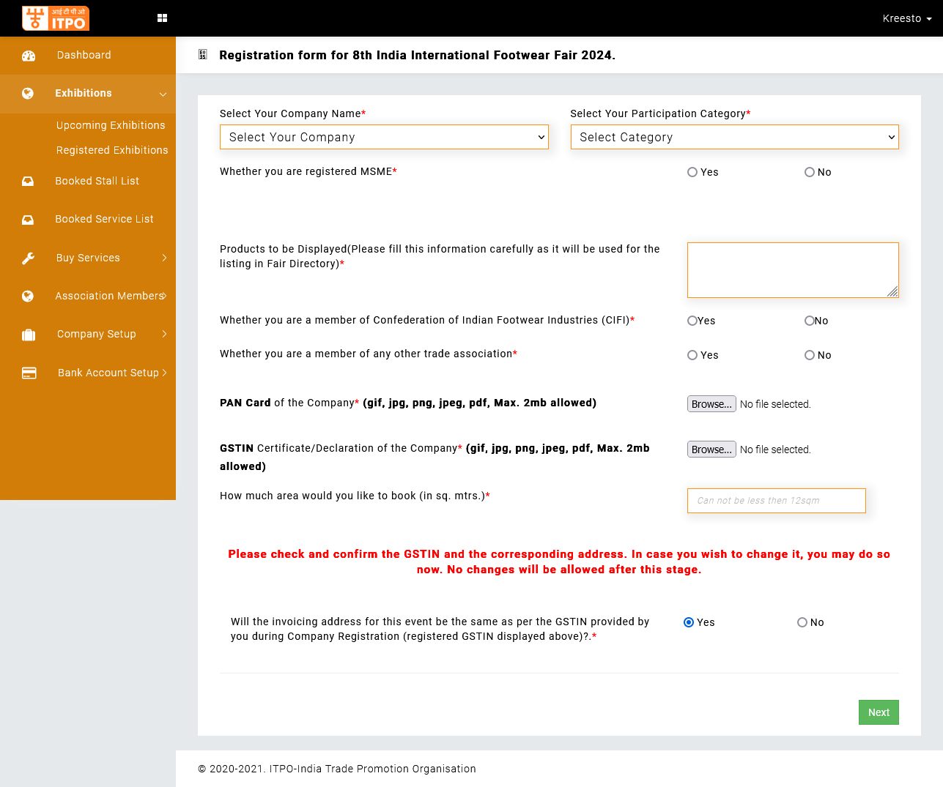

* Next you will be required to select a participation category from the drop-down list.
* Next you will be asked to reconfirm your GSTIN. Please note that the GSTIN once confirmed will not be changed under any circumstances.
* After clicking next your event registration is complete.

* After Submission you will see the following Screen :

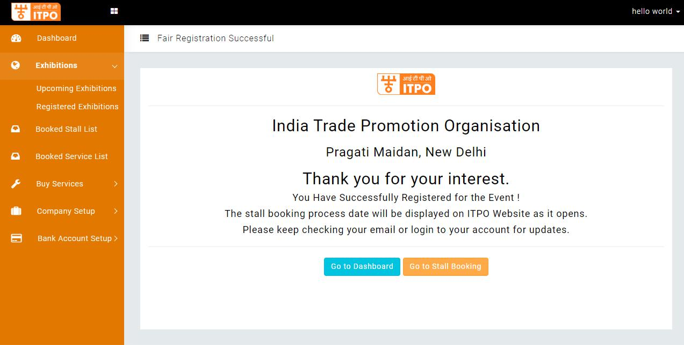

**Step 4 –** After completion of the process, you will receive SMS and Email confirmations on the same, however you can verify your Fair Registration by going to the Dashboard, where you will see your registered fair in the **GLANCE** as:

* Click on Dashboard
* You will be able to see Event Registration Status.

